**­

Bruce T. Murray

Speaks about his book

*Religious Liberty in America*

The Humanist Fellowship of San Diego (HFSD) and San Diego Secular Humanist Outreach (SD-SHOUT) Present:

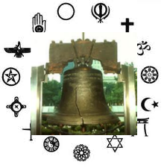

Before caption goes here

After caption goes here

**HFSD and SD-SHOUT** are proud to host local author **Bruce T. Murray** for an interesting presentation and discussion on the **Establishment and Free Exercise** clauses of the **First Amendment** and **religious liberty in the U.S.**

For over 200 years, Americans have disagreed about **the proper role of religion in public life and where to draw the line between** **church and state**. In this book, Murray reexamines these debates and distills the volumes of commentary and case law they have generated.

Throughout the book, Murray connects past and present, tracing the historical roots of modern controversies on the First Amendment.

**A noted author and journalist with 11 years of newspaper experience, Murray moved to online publishing in 2001. He operates the website** <http://websage.us/> **and is a 2nd year student at Cal Western School of Law. Murray is a versatile and thought-provoking writer who has agreed to share his insights for this event.**

**Afterwards, please join us for lunch at**

**Pete’s Grill located at 3704 Voltaire Street.**

San Diego Public Library, Point Loma/Hervey Branch

3701 Voltaire Street, San Diego

[WWW.SDSHOUT.ORG](http://WWW.SDSHOUT.ORG)

look for us on

MEETUP.COM

and check out the humanist fellowship of san diego:

**www.hfsd.info**

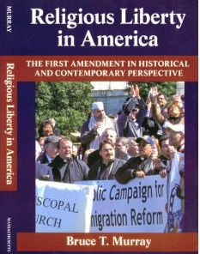

Saturday, June 4, 2011

10:00 AM